**Data Specialist Exam for Practice:**

1. **Save and Connect Data Creations:**

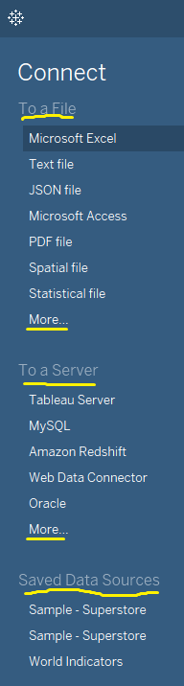

Here connection details are showing the Connect pane if we want to connect to the excel file click on –Microsoft Excel-automatically connect to excel we can use in tableau visualizations.

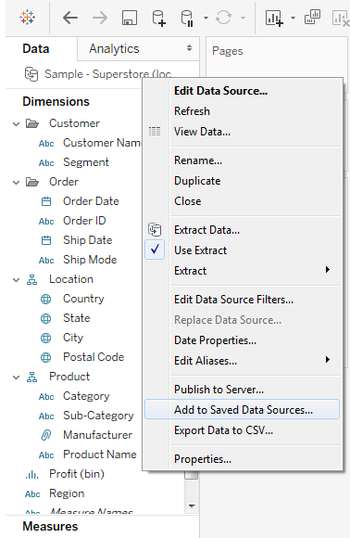

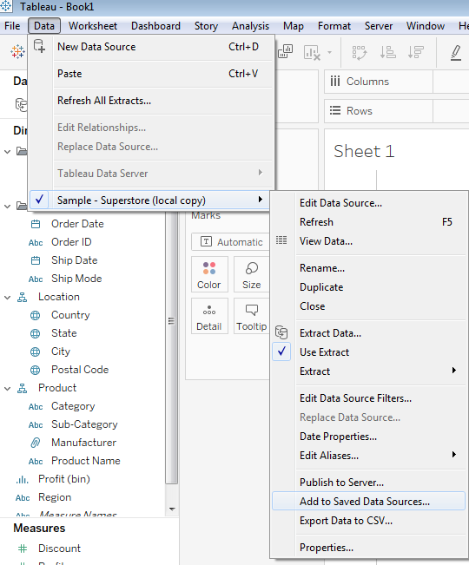

Here we can add to saved data sources. We can save as .tds and .tdsx files.

What is .tds and .tdsx files:

A TDS file tells Tableau how to use the data once it is pulled into Tableau and will include the file path to find where the data is located locally, be it an extract or an Excel file.

A TDSX file will create a zipped file which includes an extract of the data along with the metadata on how that data should be displayed in Tableau. If your users have local access to the data, just create a TDS file to avoid creating multiple copies of the same data source.

1. **Creating Extracts and Live Connections:**

Tableau Data Extracts are snapshots of data optimized for aggregation and loaded into system memory to be quickly recalled for visualization. Extracts tend to be much faster than live connections, especially in more complex visualizations with large data sets, filters, calculations, etc.

Extracts are saved subsets of data that you can use to improve performance or to take advantage of Tableau functionality not available or supported in your original data. When you create an extract of your data, you can reduce the total amount of data by using filters and configuring other limits. After you create an extract, you can refresh it with data from the original data. When refreshing the data, you have the option to either do a full refresh, which replaces all of the contents in the extract, or you can do an incremental refresh, which only adds rows that are new since the previous refresh.

Supports large data sets

Fast to create

Help improve performance

Support additional functionality

Improve offline access to your data

Beginning in version 10.5, when you create a new extract it uses the .hyper format. Extracts in the .hyper format take advantage of the improved data engine, which supports faster analytical and query performance for larger data sets.

Tableau Data Extracts are snapshots of data optimized for aggregation and loaded into system memory to be quickly recalled for visualization. Extracts tend to be much faster than live connections, especially in more complex visualizations with large data sets, filters, calculations, etc.

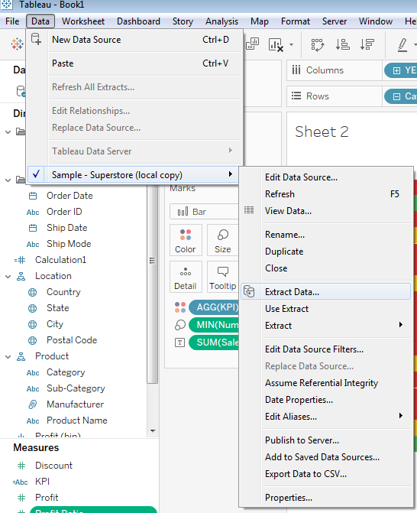

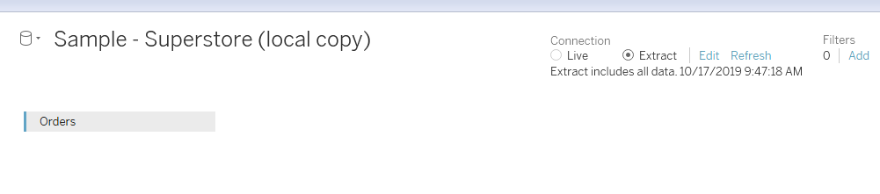

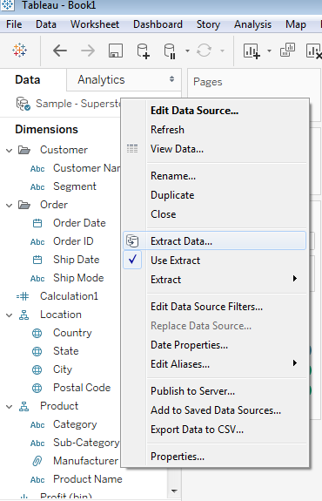

Different ways we can create the extracts in tableau, if we create extract then quick faster.

**Decide how the extract data should be stored**

You can choose to have Tableau store the data in your extract using one of two structures (schemas): single table (denormalized schema) or multiple tables (normalized schema). The option you choose depends on what you need.

**Single table**

Select **Single table** when you want to limit the amount of data in your extract with additional extract properties like extract filters, aggregation, etc.; or when your data uses pass-through functions (RAWSQL). This is the default structure Tableau uses to store extract data. If you use this option when your extract contains joins, the joins are applied when the extract is created.

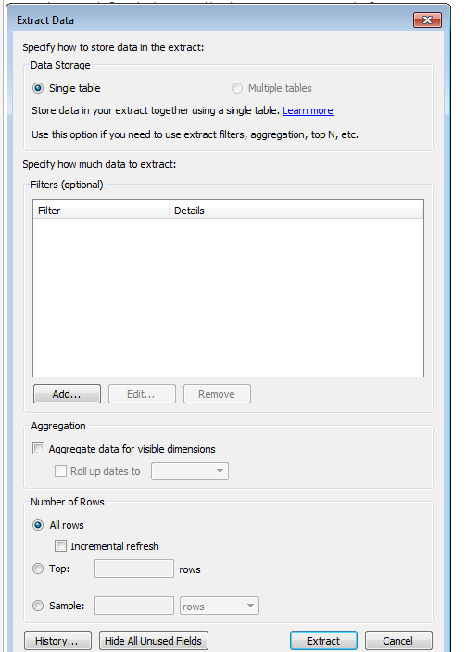

Here we can select Incremental Refresh

Full Refresh option

**Multiple tables**

Select **multiple tables** if your extract is comprised of tables combined with one or more equality joins.

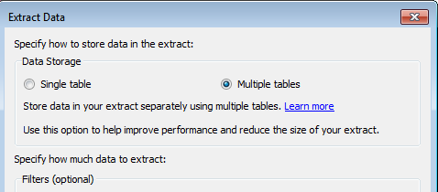

Conditions for using the "Multiple tables" option

To store your extract using the "Multiple tables" option, the data in your extract must meet all of the conditions listed below.

* All joins between tables are equality (=) joins
* Data types of the join columns are identical
* No pass-through functions (RAWSQL) used
* No incremental refresh configured
* No extract filters configured
* No top N or sampling configured

When the extract is stored as "Multiple tables," you cannot append data to it.

**Note:** Both the "Single table" and "Multiple tables" options only affect how the data in your extract is stored. The options do not affect how tables in your extract are displayed on the Data Source page.

If you open a workbook that is saved with an extract and Tableau cannot locate the extract, select one of the following options in the Extract Not Found dialog box when prompted:

* **Locate the extract:** Select this option if the extract exists but not in the location where Tableau originally saved it. Click **OK**to open an Open File dialog box where you can specify the new location for the extract file.
* **Remove the extract:** Select this option if you have no further need for the extract. This is equivalent to closing the data source. All open worksheets that reference the data source are deleted.
* **Deactivate the extract:** Use the original data source from which the extract was created, instead of the extract.
* **Regenerate the extract:** Recreates the extract. All filters and other customizations you specified when you originally created the extract are automatically applied.

